

EAST WEST UNIVERSITY

Assignment

Submitted to:

- Dr. Md. Manowarul Islam

- Adjunct faculty

- Department of Computer Science and Technology

- East West University

Submitted by:

- Name : Rakib Al Hasan

- Student ID : 2024-1-60-143

- Course Title : Data Structure and Algorithm

- Course Code : CSE 207

- Section : 10

- Semester : Summer 2025

- Date of Submission : 20.08.2025


___________________________________________________________________________
- Write a program in C to implement a stack that only allows even numbers to be pushed. Odd numbers should be rejected with an appropriate message.

Sample Input | Sample Output
Push 20  Push 23  Push 40 | Stack Contain: 20  Cannot be Inserted  Stack Contain: 20 40

#include <stdio.h>
#include <stdlib.h>

#define MAX 10

int stack[MAX], top = -1;

void push(int x)
{
if (x % 2 != 0)
{
printf("\t%d Cannot be Inserted (only even numbers allowed)!!\n" , x);
return;
}
if (top == MAX - 1)
{
printf("\tStack Overflow!!\n\tPush operation failed!!");
return;
}
stack[++top] = x;
printf("\t%d pushed to stack.\n", x);
}

void pop()
{
if (top == -1)
{
printf("\tStack Underflow (empty)!!\n\tPop operation failed!!\n");
return;
}
printf("\t%d popped from stack.\n", stack[top--]);
}

void display()
{
if (top == -1)
{
printf("\tStack is Empty!!\n");
return;
}
printf("\tStack Contains : ");
for (int i = 0; i <= top; i++)
{
printf("\t%d ", stack[i]);
}
printf("\n");
}

int main()
{
int choice, item;
//char cont = 'y';
printf("--------------------MENU--------------------\n");
printf("\tWhat type of operation do you want to perform?\n");
printf("\t1. Push\n\t2. Pop\n\t3. Display\n\t4. Exit\n\t");

while (1)
{
//system("cls");
printf("\n\tEnter your choice: ");
scanf("%d", &choice);

switch (choice)
{
case 1:
printf("\t> Your choice: Push operation\n");
printf("\t> Enter a number to push into the stack: ");
scanf("%d", &item);
push(item);
break;

case 2:
printf("\t> Your choice: Pop operation\n");
pop();
break;

case 3:
printf("\t> Your choice: Display operation\n");
display();
break;

case 4:
printf("\tBYE!!!\n");
exit(0);

default:
printf("\t>Invalid Input!!\n");
}

//printf("\n\tDo you want to continue? (y for yes/any other key for no) : ");
//scanf(" %c", &cont);
}

printf("\n\tProgram Terminated. Goodbye!!\n");
return 0;
}
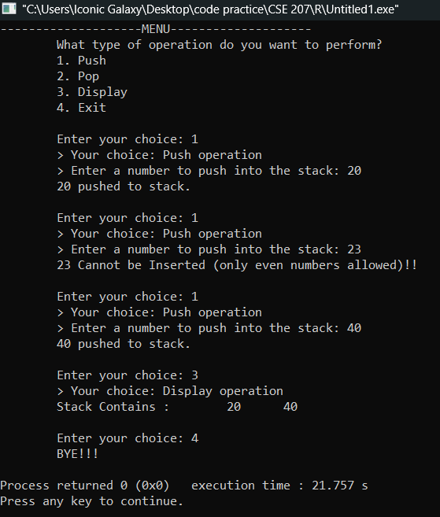

- Write a program in C to Create a stack with a constraint that the sum of all elements in the stack should never exceed 100. Prevent further pushes if adding the new element exceeds this limit.
Sample Input & Output
If current_sum + new_element > 100, reject the push and display: “Sum limit exceeded.”

#include <stdio.h>
#include <stdlib.h>

#define MAX 10

int stack[MAX], top = -1, sum = 0;

void push(int x)
{
if (sum + x > 100)
{
printf("\tSum limit exceeded. Cannot insert %d (Current Sum = %d)\n", x, sum);
return;
}
if (top == MAX - 1)
{
printf("\tStack Overflow!!\n\tPush operation failed!!");
return;
}
stack[++top] = x;
sum += x;
printf("\t%d pushed to stack. (Current Sum = %d)\n", x, sum);
}

void pop()
{
if (top == -1)
{
printf("\tStack Underflow (empty)!!\n\tPop operation failed!!\n");
return;
}
int removed = stack[top--];
sum -= removed;
printf("\tPopped element : %d (Current Sum = %d)\n", removed, sum);
}

void display()
{
if (top == -1)
{
printf("\tStack is Empty!!\n");
return;
}
printf("\tStack Contains : ");
for (int i = 0; i <= top; i++)
{
printf("%d ", stack[i]);
}
printf(" (Sum = %d)\n", sum);
}

int main()
{
int choice, item;
//char cont = 'y';
printf("--------------------MENU--------------------\n");
printf("\tWhat type of operation do you want to perform?\n");
printf("\t1. Push\n\t2. Pop\n\t3. Display\n\t4. Exit\n\t");

while (1)
{
//system("cls");
printf("\n\tEnter your choice: ");
scanf("%d", &choice);

switch (choice)
{
case 1:
printf("\t> Your choice: Push operation\n");
printf("\t> Enter a number to push into the stack: ");
scanf("%d", &item);
push(item);
break;

case 2:
printf("\t> Your choice: Pop operation\n");
pop();
break;

case 3:
printf("\t> Your choice: Display operation\n");
display();
break;

case 4:
printf("\tBYE!!!\n");
exit(0);

default:
printf("\t> Invalid Input!!\n");
}

//printf("\n\tDo you want to continue? (y for yes/any other key for no) : ");
//scanf(" %c", &cont);
}

printf("\n\tProgram Terminated. Goodbye!!\n");
return 0;
}

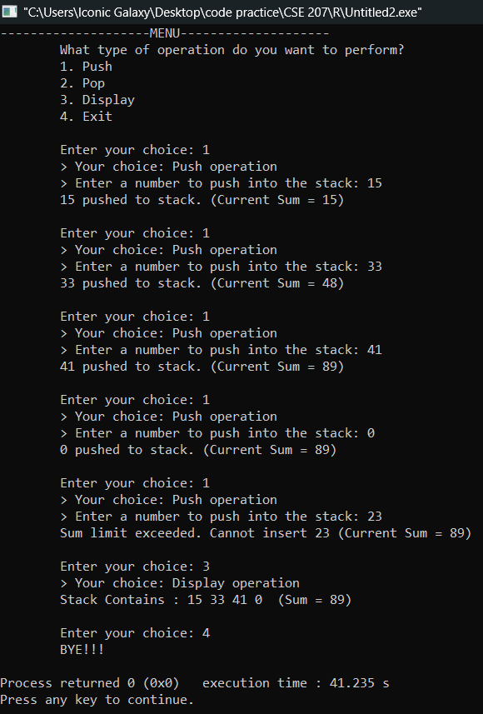

3. Write a program in C to Push N elements to the stack, then implement a function to reverse the top K elements without using any extra stack or array.
Sample Input | Sample Output
Push : 10 20 30 40 50  K=3 | Reversed Stack : 10 20 50 40 30

#include <stdio.h>
#include <stdlib.h>

#define MAX 10

int stack[MAX], top = -1;

void push(int x)
{
if (top == MAX - 1)
{
printf("\tStack Overflow!!\n\tPush operation failed!!");
return;
}
stack[++top] = x;
printf("\t%d pushed to stack.\n", x);
}

void pop()
{
if (top == -1)
{
printf("\tStack Underflow (empty)!!\n\tPop operation failed!!\n");
return;
}
printf("\t%d popped from stack.\n", stack[top--]);
}

void reverseTopK(int k)
{
if (k > top + 1)
{
printf("\tNot enough elements to reverse!!\n");
return;
}
int i = top - k + 1, j = top;
while (i < j)
{
int temp = stack[i];
stack[i] = stack[j];
stack[j] = temp;
i++;
j--;
}
printf("\tTop %d elements reversed\n", k);
}

void display()
{
if (top == -1)
{
printf("\tStack is Empty!!\n");
return;
}
printf("\tStack Contains : ");
for (int i = 0; i <= top; i++)
{
printf("\t%d ", stack[i]);
}
printf("\n");
}

int main()
{
int choice, item, k;
//char cont = 'y';
printf("--------------------MENU--------------------\n");
printf("\tWhat type of operation do you want to perform?\n");
printf("\t1. Push\n\t2. Pop\n\t3. Display\n\t4. Reverse Top K\n\t5. Exit\n\t");

while (1)
{
//system("cls");

printf("\n\tEnter your choice: ");
scanf("%d", &choice);

switch (choice)
{
case 1:
printf("\t> Your choice: Push operation\n");
printf("\t> Enter a number to push into the stack: ");
scanf("%d", &item);
push(item);
break;

case 2:
printf("\t> Your choice: Pop operation\n");
pop();
break;

case 3:
printf("\t> Your choice: Display operation\n");
display();
break;

case 4:
printf("\tEnter K : ");
scanf("%d", &k);
reverseTopK(k);
break;

case 5:
printf("\tBYE!!!\n");
exit(0);

default:
printf("\t>Invalid Input!!\n");
}

//printf("\n\tDo you want to continue? (y for yes/any other key for no) : ");
// scanf(" %c", &cont);
}

printf("\n\tProgram Terminated. Goodbye!!\n");
return 0;
}

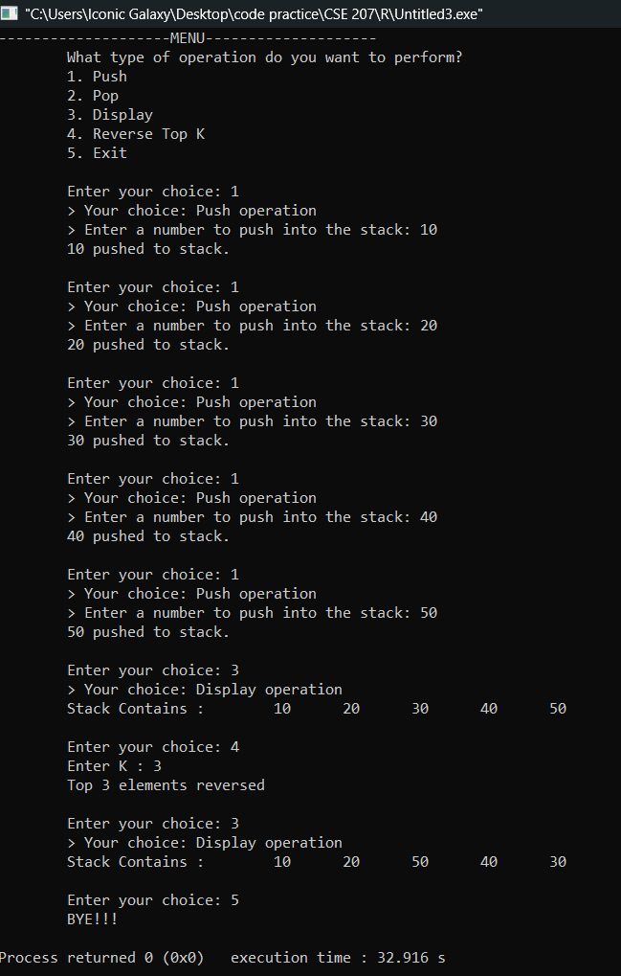
4. Write a program in C that implements a stack which ignores duplicate values during push. If an element already exists in the stack, it should not be added again.

Sample Input | Sample Output
Push 10  Push 20  Push 30  Push 20  Push 40  Push 10  Display () | Element 10 pushed to stack.  Element 20 pushed to stack.  Element 30 pushed to stack.  Duplicate entry ignored.  Element 40 pushed to stack.  Duplicate entry ignored.  Stack Contain: 10 20 30 40

#include <stdio.h>
#include <stdlib.h>
#define MAX 100

int stack[MAX], top = -1;

int exists(int x)
{
for (int i = 0; i <= top; i++)
{
if (stack[i] == x)
{
return 1;
}
}
return 0;
}

void push(int x)
{
if (exists(x))
{
printf("\t%d Cannot be Inserted (Duplicate entry ignored)!!\n" , x);
return;
}
if (top == MAX - 1)
{
printf("\tStack Overflow!!\n\tPush operation failed!!");
return;
}
stack[++top] = x;
printf("\tElement %d pushed to stack.\n", x);
}

void pop()
{
if (top == -1)
{
printf("\tStack Underflow (empty)!!\n\tPop operation failed!!\n");
return;
}
printf("\tPopped element: %d\n", stack[top--]);
}

void display()
{
if (top == -1)
{
printf("\tStack is Empty!!\n");
return;
}
printf("\tStack Contains : ");
for (int i = 0; i <= top; i++)
{
printf("\t%d ", stack[i]);
}
printf("\n");
}

int main()
{
int choice, item;
//char cont = 'y';
printf("-------------------- MENU --------------------\n");
printf("\tWhat type of operation do you want to perform?\n");
printf("\t1. Push\n\t2. Pop\n\t3. Display\n\t4. Exit\n");

while (1)
{
//system("cls");

printf("\tEnter your choice: ");
scanf("%d", &choice);

switch (choice)
{
case 1:
printf("\tYour choice: Push operation\n");
printf("\tEnter a number to push into the stack: ");
scanf("%d", &item);
push(item);
break;

case 2:
printf("\tYour choice: Pop operation\n");
pop();
break;

case 3:
printf("\tYour choice: Display operation\n");
display();
break;

case 4:
printf("\tBYE!!!\n");
exit(0);

default:
printf("\tInvalid Input!!\n");
}

//printf("\n\tDo you want to continue? (y for yes/any other key for no): ");
//scanf(" %c", &cont);
}

printf("\n\tProgram Terminated. Goodbye!!\n");
return 0;
}

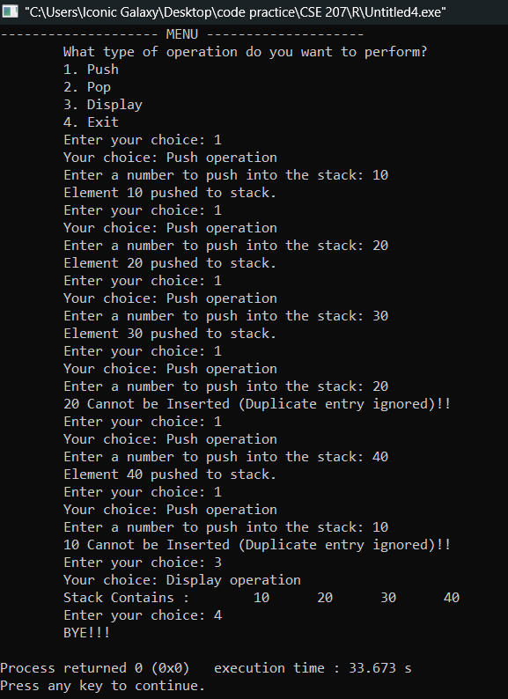

5. Write a program in C where in addition to normal peek (top), you can also peek the middle element of the stack.

Sample Input | Sample Output
Push 10  Push 20  Push 30  Display ()  Special peek () | Element 10 pushed to stack.  Element 20 pushed to stack.  Element 30 pushed to stack.  Stack Contain: 10 20 30  Middle element is 20.

#include <stdio.h>
#include <stdlib.h>

#define MAX 10

int stack[MAX], top = -1;

void push(int x)
{
if (top == MAX - 1)
{
printf("\tStack Overflow!!\n\tPush operation failed!!");
return;
}
stack[++top] = x;
printf("\tElement %d pushed to stack.\n", x);
}

void pop()
{
if (top == -1)
{
printf("\tStack Underflow (empty)!!\n\tPop operation failed!!\n");
return;
}
printf("\tPopped element: %d\n", stack[top--]);
}

void display()
{
if (top == -1)
{
printf("\tStack is Empty!!\n");
return;
}
printf("\tStack Contains : ");
for (int i = 0; i <= top; i++)
{
printf("\t%d ", stack[i]);
}
printf("\n");
}

void middlePeek()
{
if (top == -1)
{
printf("\tStack Empty\n");
return;
}
int mid = top / 2; // Middle index
printf("\tMiddle element is %d.\n", stack[mid]);
}

void peek()
{
if (top == -1)
{
printf("\tStack Empty\n");
return;
}
printf("\tTop element is %d.\n", stack[top]);
}

int main()
{
int choice, item;
//char cont = 'y';
printf("--------------------MENU--------------------\n");
printf("\tWhat type of operation do you want to perform?\n");
printf("\t1. Push\n\t2. Pop\n\t3. Display\n\t4. Peek (Top)\n\t5. Special Peek (Middle)\n\t6. Exit\n");

while (1)
{
//system("cls");

printf("\n\tEnter your choice : ");
scanf("%d", &choice);

switch (choice)
{
case 1:
printf("\tYour choice : Push operation\n");
printf("\tEnter a number to push into the stack : ");
scanf("%d", &item);
push(item);
break;

case 2:
printf("\tYour choice: Pop operation\n");
pop();
break;

case 3:
printf("\tYour choice: Display operation\n");
display();
break;

case 4:
peek();
break;

case 5:
middlePeek();
break;

case 6:
printf("\tBYE!!!\n");
exit(0);

default:
printf("\t> Invalid Input!!\n");
}

//printf("\n\tDo you want to continue? (y for yes/any other key for no) : ");
//scanf(" %c", &cont);
}

printf("\n\tProgram Terminated. Goodbye!!\n");
return 0;
}
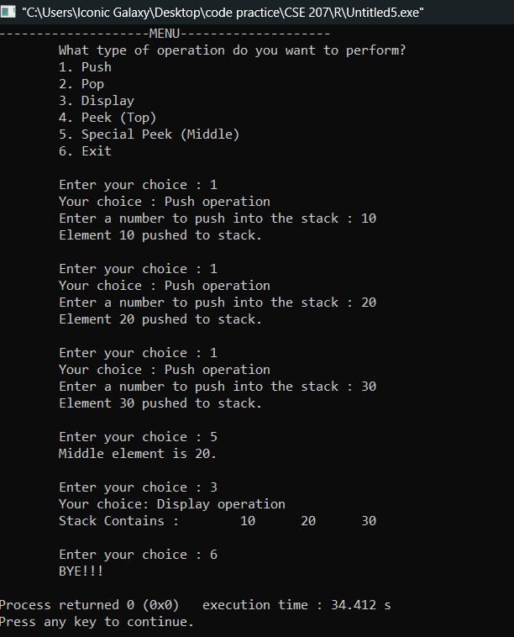
6. Write a program in C to implement a queue that only allows prime numbers to be enqueued. Non-prime numbers should be rejected with an appropriate message.

Sample Input | Sample Output
Enqueue 7  Enqueue 10  Enqueue 13  Display() | Element 7 inserted to Queue  10 is not a prime Number  Element 13 inserted to Queue.  Queue Contains: 7 13

#include <stdio.h>
#include <stdlib.h>
#include <math.h>

#define MAX 10

int queue[MAX], front = -1, rear = -1;

int isPrime(int n)
{
if (n < 2)
{
return 0;
}
for (int i = 2; i <= sqrt(n); i++)
{
if (n % i == 0)
{
return 0;
}
}
return 1;
}

void enqueue(int x)
{
if (!isPrime(x))
{
printf("\t%d is not a prime Number\n", x);
return;
}
if (rear == MAX - 1)
{
printf("\tQueue Overflow!!\n\Enqueue operation failed!!");
return;
}
if (front == -1) front = 0;
{
queue[++rear] = x;
}
printf("\tElement %d inserted to Queue\n", x);
}

void dequeue()
{
if (front == -1 || front > rear)
{
printf("\tQueue Underflow!!\n\tDequeue operation failed!!");
return;
}
printf("\tDequeued element: %d\n", queue[front++]);
}

void display()
{
if (front == -1 || front > rear)
{
printf("\tQueue Empty!!\n");
return;
}
printf("\tQueue Contains : ");
for (int i = front; i <= rear; i++)
{
printf("%d ", queue[i]);
}
printf("\n");
}

int main()
{
int choice, item;
//char cont = 'y';
printf("-------------------- MENU --------------------\n");

printf("\t1. Enqueue\n\t2. Dequeue\n\t3. Display\n\t4. Exit\n");
printf("\tWhat type of operation do you want to perform?\n");

while (1)
{
//system("cls");

printf("\tEnter your choice : ");
scanf("%d", &choice);

switch (choice)
{
case 1:
printf("\tYour choice : Enqueue operation\n");
printf("\tEnter a number to enqueue : ");
scanf("%d", &item);
enqueue(item);
break;

case 2:
printf("\tYour choice : Dequeue operation\n");
dequeue();
break;

case 3:
printf("\tYour choice: Display operation\n");
display();
break;

case 4:
printf("\tBYE!!\n");
exit(0);

default:
printf("\tInvalid Input!!\n");
}

//printf("\n\tDo you want to continue? (y for yes/any other key for no) : ");
//scanf(" %c", &cont);
}

printf("\n\tProgram Terminated. Goodbye!!\n");
return 0;
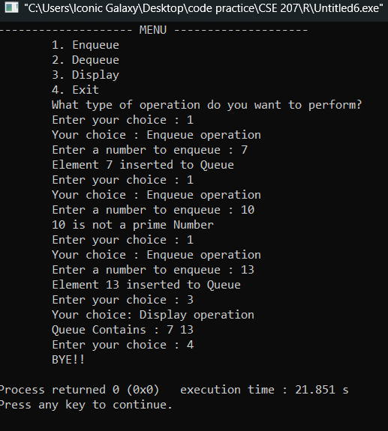
}

7. Write a program in C to implement a queue where the sum of all elements should never exceed 50. Reject new elements that would cause the sum to exceed 50.

Sample Input | Sample Output
Enqueue 20  Enqueue 15  Enqueue 18  Enqueue 10  Display () | Element 20 inserted to Queue  Element 15 inserted to Queue.  Inserting 18 would exceed sum limit (current sum = 35). Rejected  Element 10 inserted to Queue.  Queue Contains: 20 15 10

#include <stdio.h>
#include <stdlib.h>
#define MAX 100

int queue[MAX], front = -1, rear = -1, sum = 0;

void enqueue(int x)
{
if (sum + x > 50)
{
printf("\tSum limit exceeded. Cannot insert %d (Current Sum = %d)\n", x, sum);
return;
}
if (rear == MAX - 1)
{
printf("\tQueue Overflow!!\n\Enqueue operation failed!!");
return;
}
if (front == -1) front = 0;
{
queue[++rear] = x;
sum += x;
printf("\tElement %d inserted to Queue.(Current Sum = %d)\n", x, sum);
}
}

void dequeue()
{
if (front == -1 || front > rear)
{
printf("\tQueue Underflow!!\n\tDequeue operation failed!!");
return;
}
int removed = queue[front++];
sum -= removed;
printf("\tDequeued element : %d (Current Sum = %d)\n", removed, sum);
}

void display()
{
if (front == -1 || front > rear)
{
printf("\tQueue Empty!!\n");
return;
}
printf("\tQueue Contains : ");
for (int i = front; i <= rear; i++)
{
printf("%d ", queue[i]);
}
printf("\n");
}

int main()
{
int choice, item;
//char cont = 'y';
printf("-------------------- MENU --------------------\n");

printf("\t1. Enqueue\n\t2. Dequeue\n\t3. Display\n\t4. Exit\n");
printf("\tWhat type of operation do you want to perform?\n");

while (1)
{
//system("cls");

printf("\tEnter your choice : ");
scanf("%d", &choice);

switch (choice)
{
case 1:
printf("\t> Your choice : Enqueue operation\n");
printf("\tEnter a number to enqueue : ");
scanf("%d", &item);
enqueue(item);
break;

case 2:
printf("\t> Your choice : Dequeue operation\n");
dequeue();
break;

case 3:
printf("\t> Your choice: Display operation\n");
display();
break;

case 4:
printf("\tBYE!!\n");
exit(0);

default:
printf("\tInvalid Input!!\n");
}

//printf("\n\tDo you want to continue? (y for yes/any other key for no) : ");
//scanf(" %c", &cont);
}

printf("\n\tProgram Terminated. Goodbye!!\n");
return 0;
}

